Zambia

## Population Data

The data set shows the political stability estimate of the country each year.

## # A tibble: 23 x 5  
## country iso3c date population popCategory5  
## <chr> <chr> <dbl> <dbl> <chr>   
## 1 Zambia ZMB 1996 9339733 small   
## 2 Zambia ZMB 1997 9597609 small   
## 3 Zambia ZMB 1998 9866476 small   
## 4 Zambia ZMB 1999 10140561 small   
## 5 Zambia ZMB 2000 10415944 small   
## 6 Zambia ZMB 2001 10692193 small   
## 7 Zambia ZMB 2002 10971698 small   
## 8 Zambia ZMB 2003 11256743 small   
## 9 Zambia ZMB 2004 11550642 small   
## 10 Zambia ZMB 2005 11856247 small   
## 11 Zambia ZMB 2006 12173514 small   
## 12 Zambia ZMB 2007 12502958 small   
## 13 Zambia ZMB 2008 12848530 small   
## 14 Zambia ZMB 2009 13215139 small   
## 15 Zambia ZMB 2010 13605984 small   
## 16 Zambia ZMB 2011 14023193 small   
## 17 Zambia ZMB 2012 14465121 small   
## 18 Zambia ZMB 2013 14926504 small   
## 19 Zambia ZMB 2014 15399753 small   
## 20 Zambia ZMB 2015 15879361 small   
## 21 Zambia ZMB 2016 16363507 small   
## 22 Zambia ZMB 2017 16853688 small   
## 23 Zambia ZMB 2018 17351822 small

# Population growth data

## # A tibble: 23 x 5  
## country iso3c date popGrowth popGrowthCat5   
## <chr> <chr> <dbl> <dbl> <chr>   
## 1 Zambia ZMB 1996 2.64 high growth rate  
## 2 Zambia ZMB 1997 2.72 high growth rate  
## 3 Zambia ZMB 1998 2.76 high growth rate  
## 4 Zambia ZMB 1999 2.74 high growth rate  
## 5 Zambia ZMB 2000 2.68 high growth rate  
## 6 Zambia ZMB 2001 2.62 high growth rate  
## 7 Zambia ZMB 2002 2.58 high growth rate  
## 8 Zambia ZMB 2003 2.56 high growth rate  
## 9 Zambia ZMB 2004 2.58 high growth rate  
## 10 Zambia ZMB 2005 2.61 high growth rate  
## 11 Zambia ZMB 2006 2.64 high growth rate  
## 12 Zambia ZMB 2007 2.67 high growth rate  
## 13 Zambia ZMB 2008 2.73 high growth rate  
## 14 Zambia ZMB 2009 2.81 high growth rate  
## 15 Zambia ZMB 2010 2.91 high growth rate  
## 16 Zambia ZMB 2011 3.02 high growth rate  
## 17 Zambia ZMB 2012 3.10 high growth rate  
## 18 Zambia ZMB 2013 3.14 high growth rate  
## 19 Zambia ZMB 2014 3.12 high growth rate  
## 20 Zambia ZMB 2015 3.07 high growth rate  
## 21 Zambia ZMB 2016 3.00 high growth rate  
## 22 Zambia ZMB 2017 2.95 high growth rate  
## 23 Zambia ZMB 2018 2.91 high growth rate

## Population trend

The plot shows the population trend of the country.

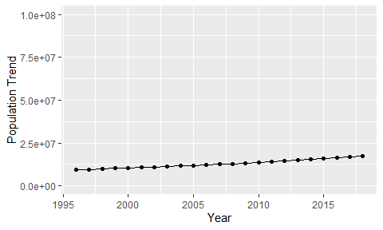

Political Stability Trend

# Population growth trend

The plot shows the population growth rate trend of the country.

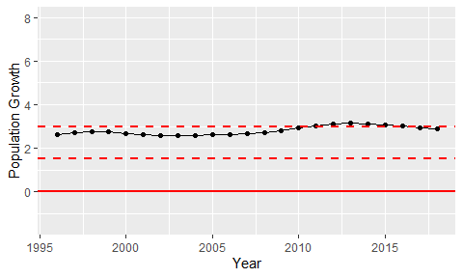

Population Growth Trend